**Lesson 6 Demo 2**

**How to Apply Chart Formatting**



**Steps to be followed:**

**Step 1: Open the Excel file**

* 1. Open the file named **Chart.xlsx** and click on the **Chart Formatting** worksheet

**Step 2: Create a chart**

2.1 Choose the data in the sheet

2.2 Click on the **2-D Column** Chartunder the **Insert** tab

2.3 The chart is created. Click on **Change Chart Type**

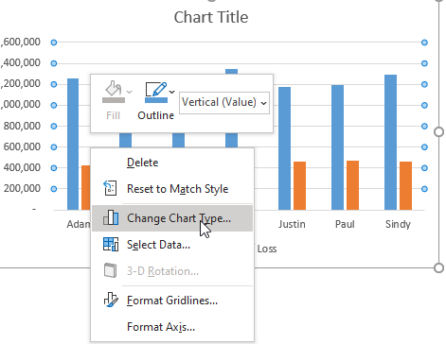

2.4 In the **Change Chart Type** dialog, click on the **Combo** tab. The clustered column is selected. Click OK

2.5 The created chart looks as shown below:

2.6 Right-click on the vertical axis and click on **Format Axis**

2.7 Change the Maximum bound to 150000

2.8 The final chart looks as shown below: